# ****CS-350 Module 7 Reflection: Thermostat State Machine Implementation****

**Emireth Castro**  
Southern New Hampshire University  
CS-350: Emerging Systems Architecture and Technologies

## ****Reflection****

The purpose of the CS-350 Module 7 Thermostat project was to design and implement a functional thermostat using a state machine approach. This project required integrating Python programming, button-driven user input, temperature monitoring, LED indicators, and multithreaded execution. Through this assignment, I gained a deeper understanding of how state machines simplify system control logic and how embedded-style applications manage hardware interactions in a predictable and maintainable way.

At program startup, the thermostat initializes in the OFF state with a default setpoint of 72 degrees Fahrenheit. This behavior confirms proper initialization and validates that the system begins in a safe and idle condition. The OFF state disables all LEDs, which reinforces the concept that no heating or cooling action should occur when the system is inactive. This initial design decision demonstrates good embedded system practice by preventing unintended outputs during startup.

The core of this project is the state machine logic that controls transitions between OFF, HEAT, and COOL modes. The thermostat cycles through these states in a defined order, and each transition is clearly confirmed through console output. This predictable sequence highlights one of the major advantages of state machines: clarity. By restricting the system to known states and transitions, the code becomes easier to debug, extend, and reason about. This approach significantly reduces the likelihood of unexpected behavior.

In HEAT mode, the thermostat compares the current temperature to the setpoint to determine LED behavior. When the temperature is above the setpoint, the red LED remains solid, indicating that heating is not actively required. If the temperature were below the setpoint, the red LED would pulse, signaling active heating. This conditional logic confirms that the system responds appropriately to environmental data and accurately reflects heating behavior through visual indicators.

Similarly, in COOL mode, the thermostat activates the blue LED when the temperature exceeds the setpoint. The pulsing blue LED indicates that cooling is required, while the red LED is turned off to avoid conflicting signals. This mutually exclusive LED behavior ensures clarity for the user and reflects real-world thermostat design principles.

Button functionality was another key component of this project. Each button was assigned a single, clearly defined purpose. The red button cycles through the thermostat states, the green button increases the temperature setpoint, and the blue button decreases the setpoint. This separation of responsibilities improves usability and reduces complexity. Implementing this logic reinforced the importance of designing intuitive user interfaces, even in simple embedded systems.

The project also introduced multithreading through a display management thread. This thread continuously updates the display output and prints debug information without blocking the main execution flow. The recurring “Processing Display Info” messages and counter increments demonstrate that the program remains stable during extended execution. This experience provided valuable insight into concurrency and reinforced the importance of non-blocking system design.

Occasional temperature read errors were observed during execution due to hardware input/output limitations. These errors were handled gracefully by falling back to the last known valid temperature. This approach ensured system stability and prevented crashes, highlighting the importance of defensive programming and error handling in embedded applications. Additionally, the program exits cleanly when interrupted, releasing resources properly and demonstrating good shutdown practices.

Overall, this project successfully integrates state machine logic, hardware abstraction, user input handling, and multithreaded execution into a cohesive system. It reinforced how structured design patterns, such as finite state machines, make complex behavior easier to implement and maintain. The skills developed in this module directly apply to real-world embedded systems, automation, and control applications.

## ****References****

Gamma, E., Helm, R., Johnson, R., & Vlissides, J. (1994). Design patterns: Elements of reusable object-oriented software. Addison-Wesley.

Lee, E. A., & Seshia, S. A. (2017). Introduction to embedded systems: A cyber-physical systems approach (2nd ed.). MIT Press.

### OFF State Initialization

**Description:**  
This screenshot shows the thermostat initialized in the **OFF state**. The LCD display indicates the current temperature and setpoint while no LED indicators are active. This confirms correct startup behavior and validates that the system begins in a safe, idle state with no heating or cooling engaged.

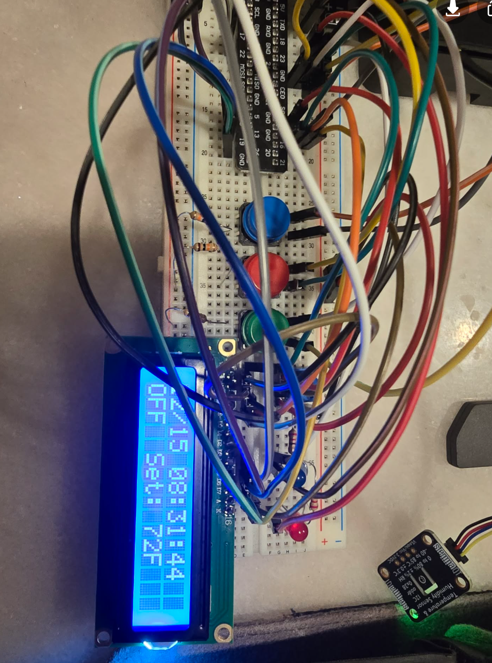

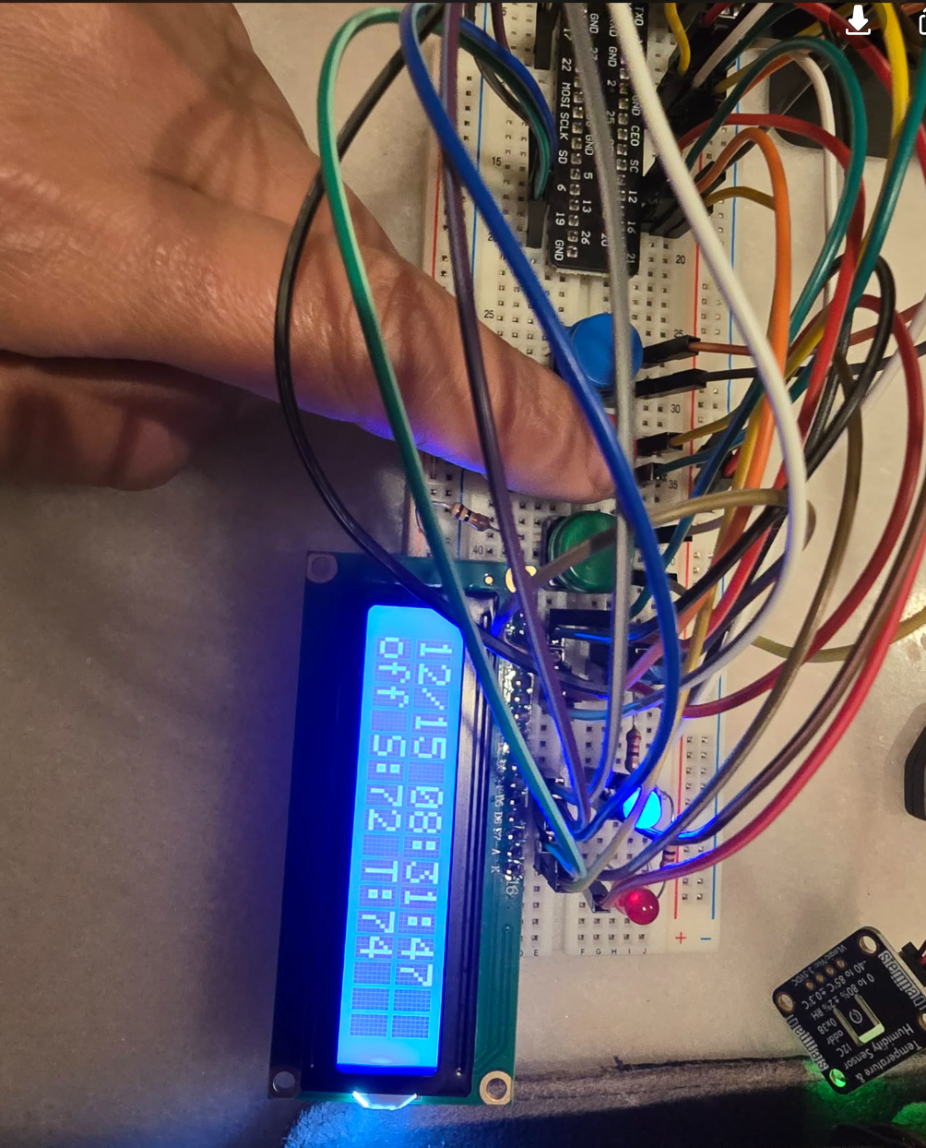

### COOL State Activated

**Description:**  
This screenshot shows the thermostat after cycling into **COOL mode** using the red button. The LCD updates to display “COOL,” and the **blue LED is active**, indicating cooling functionality. This confirms proper state sequencing and state machine execution.

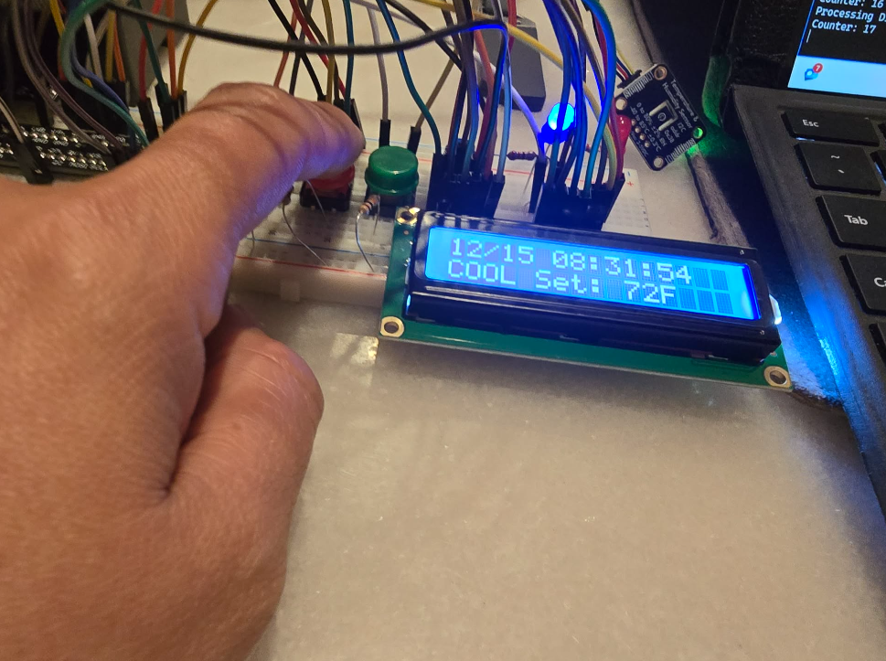

### COOL State Activated

**Description:**  
This screenshot shows the thermostat after cycling into **COOL mode** using the red button. The LCD updates to display “COOL,” and the **blue LED is active**, indicating cooling functionality. This confirms proper state sequencing and state machine execution.

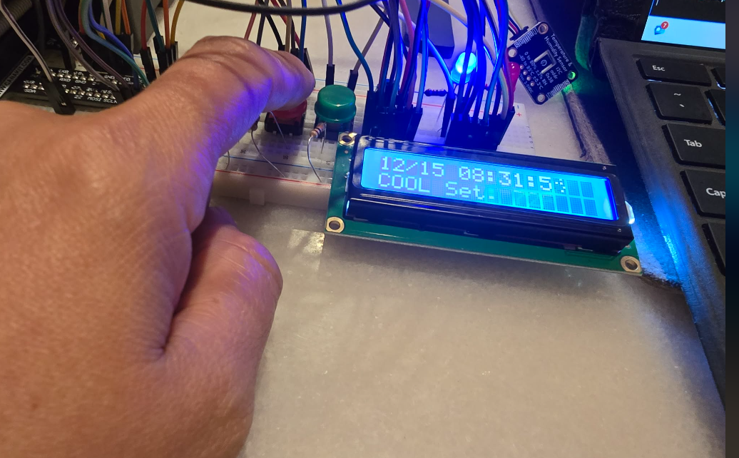

### COOL Mode Temperature Response

**Description:**  
Here, the thermostat remains in COOL mode with the current temperature above the setpoint. The blue LED pulses, indicating active cooling is required. This demonstrates correct cooling logic and exclusive LED control.

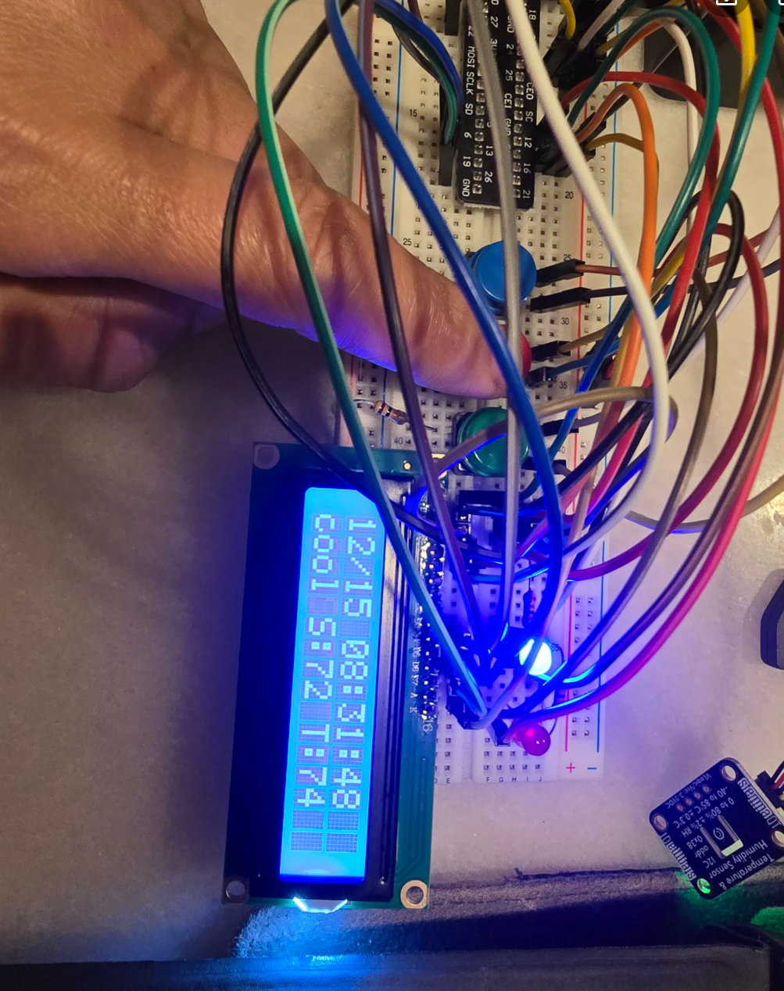

### HEAT State Activated

**Description:**  
This screenshot captures the thermostat operating in **HEAT mode** after a red button press. The LCD displays “HEAT” along with the current setpoint and temperature. The **red LED is illuminated**, indicating heating mode is active. This confirms a successful state transition from OFF to HEAT.

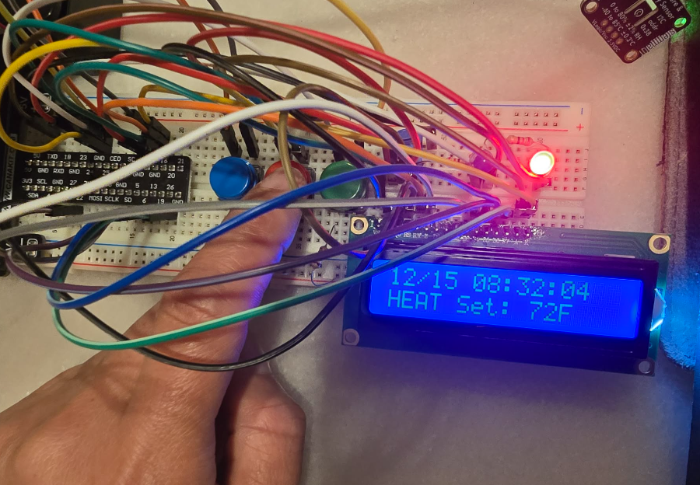

### Setpoint Adjustment via Buttons

**Description:**  
This image demonstrates temperature setpoint adjustment using the **green (increase)** and **blue (decrease)** buttons. The setpoint value updates on the LCD without changing the current thermostat state, confirming correct button mapping and separation of responsibilities.

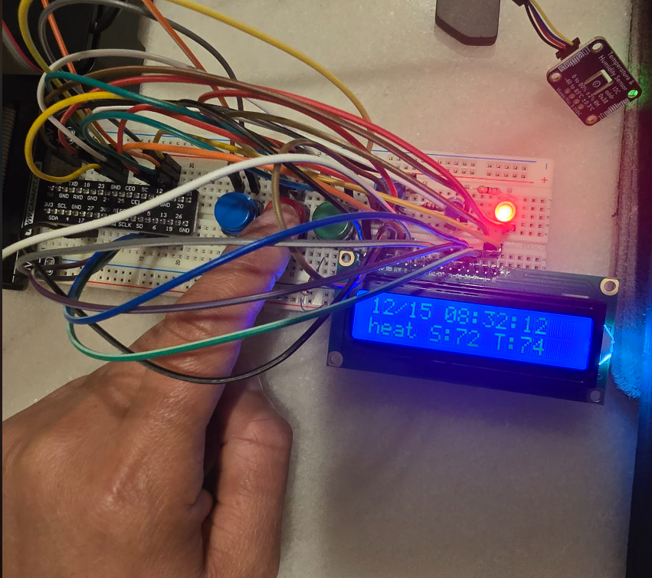 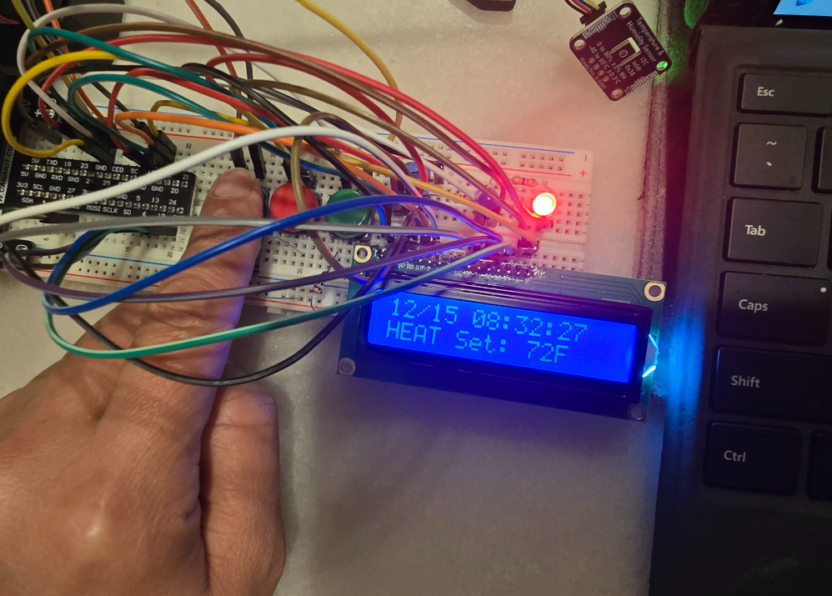

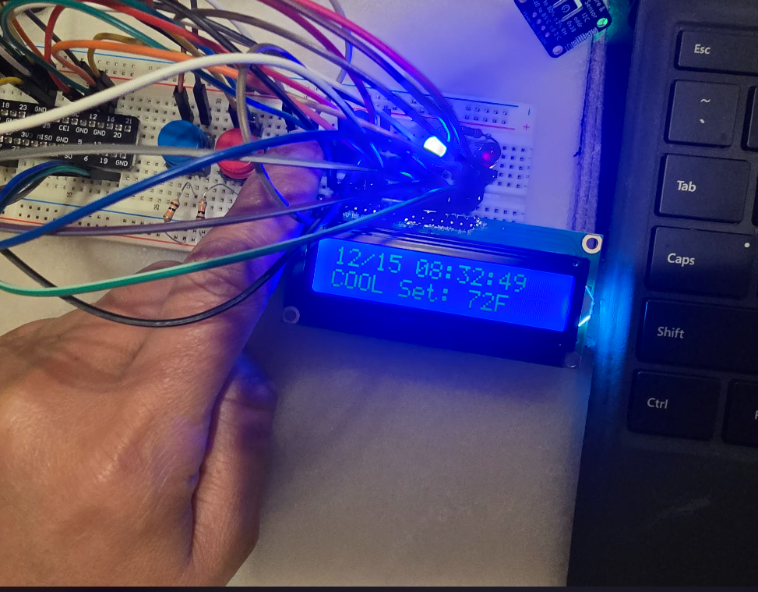 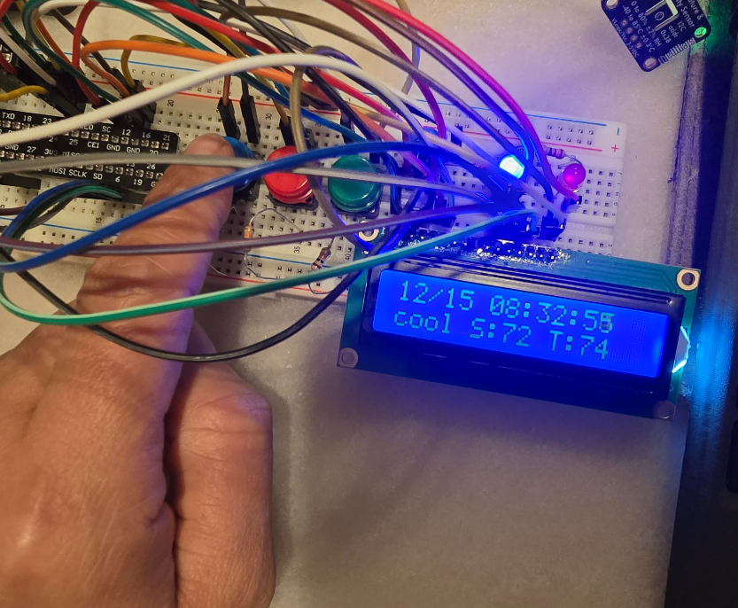

### HEAT Mode Temperature Comparison

**Description:**  
In this image, the thermostat remains in HEAT mode while comparing the current temperature to the setpoint. Because the temperature is above the setpoint, the red LED remains solid rather than pulsing, demonstrating correct conditional logic within the HEAT state.

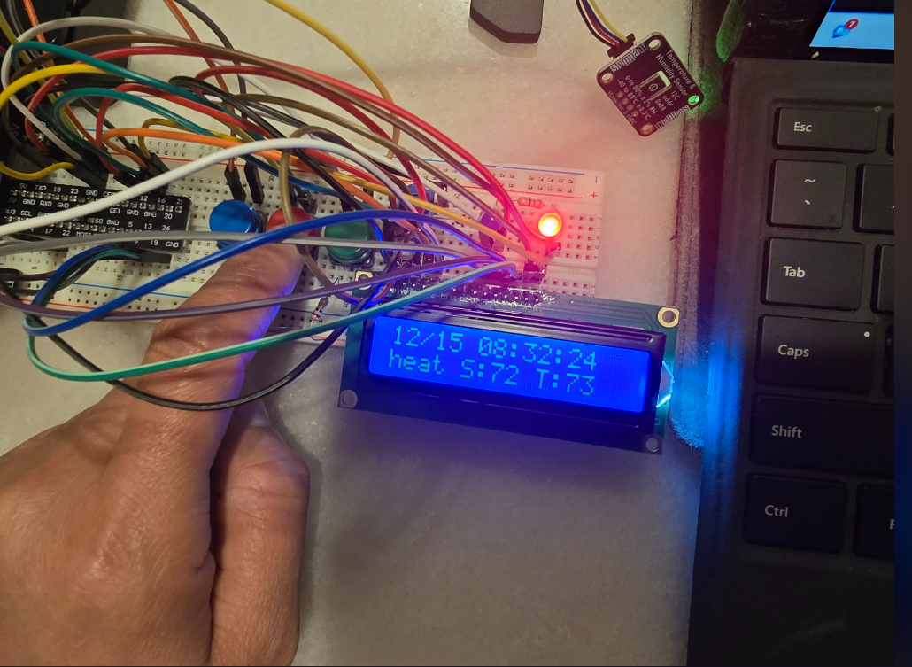

### OFF State After Cycling

**Description:**  
This screenshot shows the thermostat returning to the OFF state after cycling through HEAT and COOL. The LCD confirms the OFF state, and all LEDs are disabled, verifying proper wraparound behavior of the state machine.

